TechXpress E-commerce Platform for Electronics

# Project Planning and Management

## Team Members:

* + **Member 1:** Mahmoud atef
  + **Member 2:** Alaa Mohamed
  + **Member 3:** Mohamed Ayman
  + **Member 4:** Yehia Zakaria
  + **Member 5:** Abdelrhman ahmed ezzat

**Submission Date**: 21 March 2025

**DIGITAL EGYPT PIONEERS INITIATIVE**

1. PLANNING & MANAGMENT 1
   * Table of Contents
2. Project Proposal: TechXpress E-commerce Platform 1
   * 1.1 Project Title 1
   * 1.2 Overview 1
   * 1.3 Objectives 2
   * 1.4 Scope 3
   * 1.5 Technologies 3
   * 1.6 Key Benefits 4
3. Project Plan 5
   * 2.1 Timeline (Gantt Chart) 5
   * 2.2 Milestones 6
   * 2.3 Deliverables 7
   * 2.4 Resource Allocation 8
4. Task Assignment & Roles 9
   * 3.1 Overview 9
   * 3.2 Team Roles and Responsibilities 10
   * 3.3 Weekly Task Breakdown 12
5. Risk Assessment & Mitigation Plan 14
   * 4.1 Overview 14
   * 4.2 Identified Risks and Mitigation Strategies 15
   * 4.3 Contingency Plan 17
6. KPIs (Key Performance Indicators) 18
   * 5.1 Overview 18
   * 5.2 KPIs and Targets 19
   * 5.3 Monitoring and Reporting 20
7. Conclusion 21
   * 6.1 Summary of the Project Plan 21
   * 6.2 Next Steps 22
   * 6.3 Future Enhancements 23

* **1. Project Proposal: TechXpress E-commerce Platform**

## Project Title :

TechXpress E-commerce Platform for Electronics

---

## Overview:

TechXpress is a **full-stack e-commerce platform** built using **ASP.NET Core** for selling electronics products such as laptops, mobiles, and cameras. The platform provides a seamless shopping experience for users, allowing them to browse products, add items to their cart, and complete purchases securely using integrated payment gateways. Additionally, it includes an **admin panel** for managing products, categories, and orders.

The project follows **professional software engineering practices,** to ensure scalability, maintainability, and separation of concerns.

---

## Objectives:

### User-Facing Features:

* + Product browsing with search and filtering.
  + Shopping cart functionality with session management.
  + Secure checkout process with **Stripe payment integration.**
  + User profiles with order history and account management.

### Admin-Facing Features:

* Admin dashboard for managing users, products, categories, and orders.
* Role-based access control (RBAC) for admin and customer roles.

### Technical Goals:

* Ensure a responsive and modern UI using **Bootstrap, JQuery,** and **DataTables.**
* Deploy the platform on **Monster Server** for live use.

## Scope:

### Included Features:

* + Product listings with search and filters.
  + Shopping cart and checkout functionality.
  + Secure payment integration using Stripe.
  + Admin panel for product and order management.
  + User authentication and role-based access control.

### Excluded Features:

* + Physical product delivery and inventory management.
  + Advanced features like AI-based recommendations or multi-language support.

---

## Technologies:

* **Frontend:** HTML, CSS, JavaScript, Bootstrap, JQuery, DataTables.
* **Backend:** ASP.NET Core MVC, Entity Framework Core.
* **Database:** SQL Server.
* **Authentication:** ASP.NET Identity.
* **Payment Gateway:** Stripe.
* **Deployment**: Monster Server.

---

## Key Benefits:

* **Scalability:** ensures the platform can grow with increasing user demand.
* **Maintainability:** The Separation of concerns and design patterns makes the codebase easy to maintain and extend.
* **Security:** Secure payment integration and role-based access control protect user data and transactions.
* **User Experience:** A responsive and intuitive UI enhances customer satisfaction.

—

# 2. Project Plan

## Timeline (Gantt Chart)

The project will be completed by **9th May,** divided into **4 weeks** with clear milestones and deliverables. Below is the timeline:

|  |  |  |  |  |  |
| --- | --- | --- | --- | --- | --- |
| **Task** | **Start Date** | **End Date** | **Duration** | **Assigned To** | **Dependencies** |
| **phase 1: Initial Setup** |  |  |  |  |  |
| Project Planning and Management | 1 Mar | 5 Mar | 4 days | Member 2 |  |
| Problem Statement & Objectives | 1Mar | 5Mar | 4 days | Member 5 |  |
| Architecture Setup | 5 Mar | 8 Mar | 3 days | Member 1 |  |
| Database Design & Modeling | 5 Mar | 8 Mar | 3 days | Member 1 |  |
| Data Flow & System Behavior | 5 Mar | 8 Mar | 3 days | Member 5 |  |
| System Deployment & Integration | 8 Mar | 12 Mar | 4 days | Member 1 |  |
| UI/UX Design & Prototyping | 25 Mar | 30 Mar | 5 days | Member 3,4 |  |
| User Authentication Setup | 25 Mar | 30 Mar | 5 days | Member 1 | Database Design |
| **phase 2: Core Features** |  |  |  |  |  |
| Shopping Cart Implementation | 22 Apr | 24 Apr | 3 days | Member 1,  Member 2 |  |
| Role-Based Access Control (RBAC) | 22 Apr | 24 Apr | 3 days | Member 3 | User Authentication Setup |
| Admin Dashboard Development | 25 Apr | 26 Apr | 2 days | Member 4 | RBAC Implementation |
| **phase 3: Advanced Features** |  |  |  |  |  |
| Order Placement | 29 Apr | 1 May | 3 days | Member 2 | Shopping Cart |
| Stripe Payment Integration | 29 Apr | 1 May | 3 days | Member 4 | Order Placement |
| User Profiles & Order History | 2 May | 3 May | 2 days | Member 3 | Stripe Integration |
| **phase 4: Finalization** |  |  |  |  |  |
| UI Enhancements | 6 May | 7 May | 2 days | Member 1 | User Profiles |
| Final Testing | 6 May | 7 May | 2 days | Member 5 | UI Enhancements |
| Deployment to Microsoft Azure | 8 May | 9 May | 2 days | Member 4 | Final Testing |

## Milestones

### phase 1:

* + Database schema designed and implemented.
  + User authentication system integrated.

### phase 2:

* + Shopping cart functionality implemented.
  + Role-based access control (RBAC) configured.
  + Admin dashboard created.

### phase 3:

* + Order placement and Stripe payment integration completed.
  + User profiles and order history implemented.

### phase 4:

* + UI enhancements finalized.
  + Comprehensive testing completed.
  + Platform deployed to Microsoft Azure.

---

## Deliverables :

### phase 1:

* + Product listing page with search and filters.
  + Database schema with repositories and Unit of Work.
  + User authentication system.

### phase 2:

* + Functional shopping cart.
  + Role-based access control (RBAC).
  + Admin dashboard for product and order management.

### phase 3:

* + Order placement with Stripe payment integration.
  + Customer profile page with order history.

### phase 4:

* + Polished, responsive UI.
  + Fully tested platform.
  + Live deployment on Monster Server.

---

# 3. Task Assignment & Roles

## Overview

To ensure a **collaborative and efficient workflow**, all **5 team members** will work together on all aspects of the development process. While each member has a **primary role,** everyone will contribute to **frontend, backend, database, and testing tasks** to foster teamwork and shared understanding of the project. Below is the detailed breakdown:

---

## Team Roles and Responsibilities

### Frontend Development (All Members):

#### Tasks:

* + - Designed and developed the **user interface (UI)** using **HTML, CSS, JavaScript, Bootstrap, and JQuery.**

#### Create the product listing page, shopping cart UI, checkout page, and admin dashboard.

* + - Ensure the platform is **responsive** and works seamlessly on all devices.

#### Collaboration:

* + - **Member 1** leads the UI design.
    - **Members 2, 3, 4, and 5** assist in implementing UI components and testing responsiveness.

### Backend Development (All Members):

#### Tasks:

* + - Develop the **Business Logic Layer** using **ASP.NET Core.**

#### Implement shopping cart logic, order placement logic, and payment integration.

* + - Create **MVC project** for communication between the frontend and back end.

#### Collaboration:

* + - **Member 1** leads backend development.
    - **Members 2, 3, 4, and 5** assist in writing business logic, integrating APIs, and testing functionality.

### Payment Integration and Security (All Members):

#### Tasks:

* + - Integrate **Stripe payment gateway** for secure transactions.

#### Implement user authentication and role-based access control (RBAC).

* + - Ensure **data validation and security best practices** (e.g., HTTPS, encryption).

### Collaboration:

* + **Member 1** leads payment integration and security.
  + **Members 2, 3, 4, and 5** assist in integrating Stripe, testing security features, and fixing vulnerabilities.

### Testing and Deployment (All Members):

#### Tasks:

* + - Perform **unit testing, integration testing, and user acceptance testing (UAT).**
    - Fix bugs and optimize performance.
    - Deploy the platform to **Microsoft Azure**.

### Collaboration:

* + **Member 1** leads testing and deployment.
  + **Members 2, 3, 4, and 5** assist in testing, bug fixing, and preparing the platform for deployment.

---

# 4. Risk Assessment & Mitigation Plan

### Overview

To ensure the successful completion of the TechXpress e-commerce platform, the team has identified potential risks and developed strategies to mitigate them. This plan focuses on

**technical, operational, and timeline-related risks**.

---

### Identified Risks and Mitigation Strategies

1. **Risk**: Delays in Development Due to Technical Challenges
   * **Description**: Complexities in implementing the **NTier Architecture**, **Stripe payment integration**, or **role-based access control (RBAC)**could cause delays.

#### Mitigation:

* + - Break tasks into smaller, manageable chunks.
    - Use well-documented libraries and frameworks (e.g., Stripe API, ASP.NET Identity).
    - Conduct daily stand-up meetings to address technical blockers quickly.

### Risk: Integration Issues Between Frontend and Backend

* + **Description:** Miscommunication or mismatched APIs between the frontend and backend could lead to integration problems.

#### Mitigation:

* + - Define clear API contracts early in the project.
    - Use tools like **Swagger** for API documentation.
    - Conduct frequent integration testing.

### Risk: Security Vulnerabilities

* + **Description:** The platform could be exposed to risks like **SQL injection, XSS attacks, or data breaches.**

#### Mitigation:

* + - Implement **input validation** and **parameterized queries** to prevent SQL injection.
    - Use **HTTPS** for secure communication.
    - Regularly test the platform for vulnerabilities using tools like **OWASP ZAP**.

### Risk: Poor User Adoption Due to Complex UI

* + **Description:** A complicated or non-intuitive user interface could discourage users from adopting the platform.

#### Mitigation:

* + - Conduct **user testing** early in the development process.
    - Use **Bootstrap** and **JQuery** to create a clean, responsive, and user-friendly interface.
    - Gather feedback from potential users and iterate on the design.

### Risk: Deployment Failures

* + **Description**: Issues during deployment to **Monster Server Cloud** delay the project launch.

### Mitigation:

* + Test the deployment process in a staging environment before going live..
    - Assign a dedicated team member **(Member 4)** to oversee deployment.

---

### Contingency Plan

* If a critical risk materializes (e.g., Stripe integration fails), the team will:
  1. Escalate the issue immediately to the **Project Manager (Member 5)**.
  2. Allocate additional resources to resolve the issue.
  3. Adjust the timeline if necessary, prioritizing critical features.

---

# 5. KPIs (Key Performance Indicators)

### Overview

To measure the success of the TechXpress e-commerce platform, the team has defined **Key Performance Indicators (KPIs).** These metrics will help evaluate the platform's performance, usability, and adoption.

---

## KPIs and Targets

### Response Time

* + **Definition:** The time taken for the platform to load pages and process requests.
  + **Target**: Less than **2 seconds** for page load and API responses.
  + **Measurement**: Use tools like **Google PageSpeed Insights** or **Postman** to monitor response times.

### System Uptime

* + **Definition**: The percentage of time the platform is operational and accessible to users.
  + **Target**: **99.9% uptime** during the first month of deployment.
  + **Measurement**: Use monitoring tools like **UptimeRobot** to track uptime.

### User Adoption Rate

* + **Definition:** The number of users registering and actively using the platform.
  + **Target**: At least **100 registered users** in the first month.
  + **Measurement**: Track user registrations using **Google Analytics** or the platform's admin dashboard.

### Conversion Rate

* + **Definition:** The percentage of visitors who complete a purchase.
  + **Target**: At least **5% conversion rate** in the first month.
  + **Measurement:** Use the platform's analytics dashboard to track conversions.

### Bug Resolution Time

* + **Definition:** The average time taken to resolve reported bugs.
  + **Target:** Less than **24 hours** for critical bugs and **48 hours** for minor bugs.
  + **Measurement:** Track bug resolution times using **Trello** or **Jira**.

---

## Monitoring and Reporting

* **Weekly KPI Reviews:** The team will review KPIs during weekly meetings to identify areas for improvement.
* **Monthly Reports:** Generate monthly reports summarizing KPI performance and share them with stakeholders.

---

# 6.Conclusion

### Summary of the Project Plan

The TechXpress e-commerce platform is a **full-stack ASP.NET Core project** designed to provide a seamless shopping experience for electronics products. By following a **structured timeline**, leveraging **professional design patterns** (e.g., NTier Architecture, Repository Pattern), and addressing potential risks, the team aims to deliver a **scalable, secure, and user- friendly platform**.

The project emphasizes **team collaboration**, with all members contributing to **frontend, back- end, database, and testing tasks**. Key features like **Stripe payment integration**, **role-based access control**, and a **responsive UI** will ensure the platform meets both user and business needs.

# Requirements Gathering & System Analysis and Design

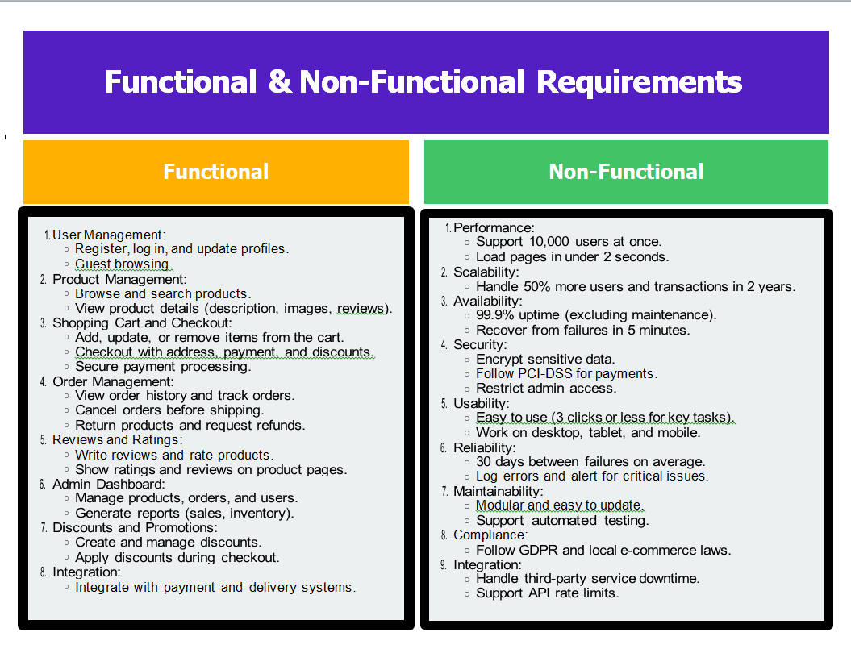

Use Case Diagram

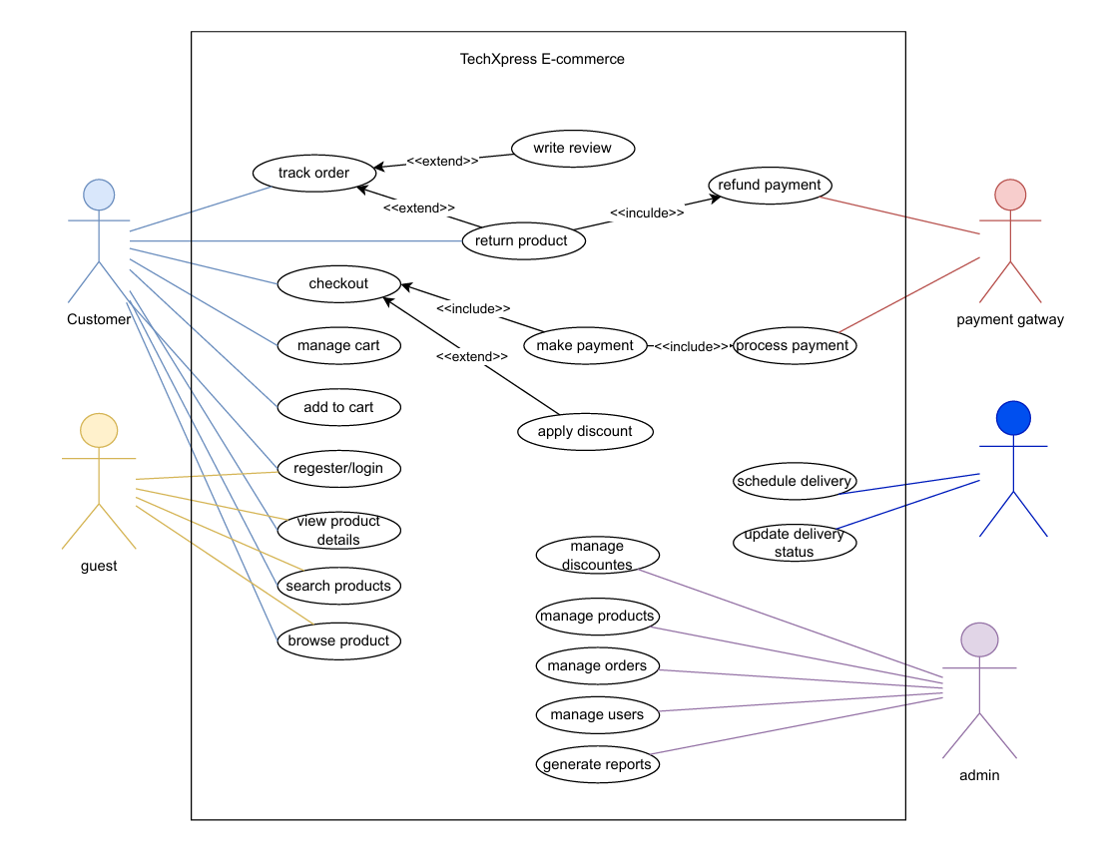

Software Architecture

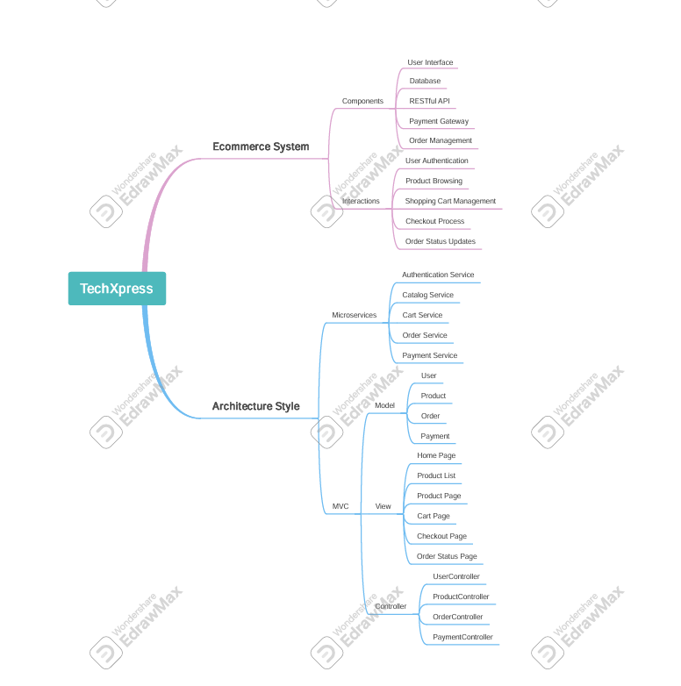

Data Flow Diagram

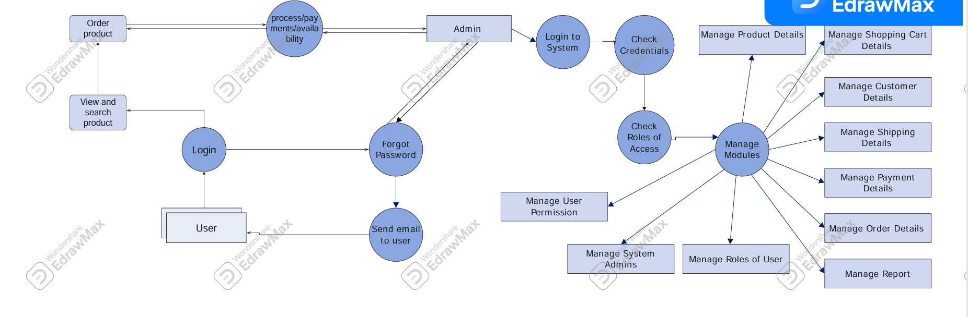

Actevity Diagram

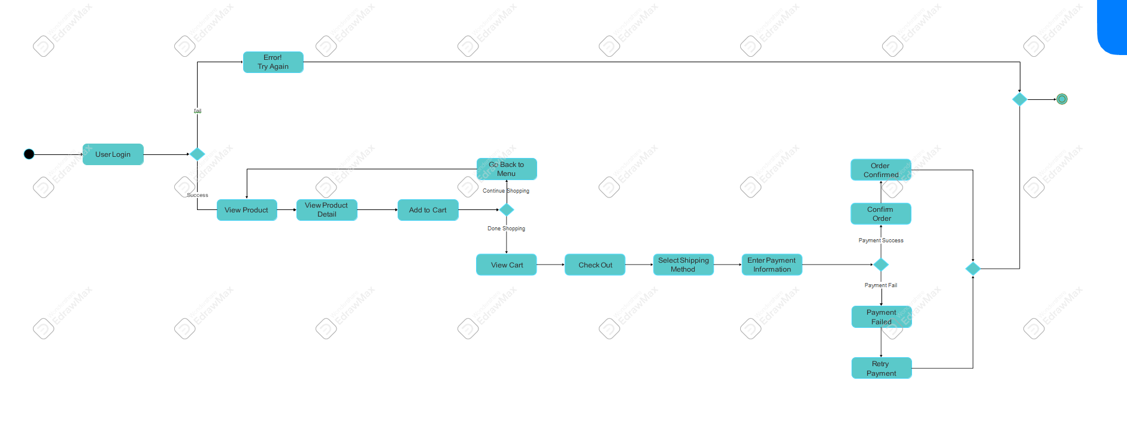

Sequence Diagram

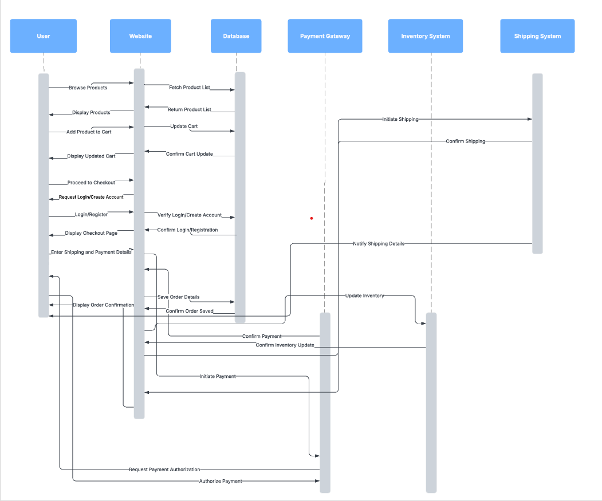

# System Deployment & Integration

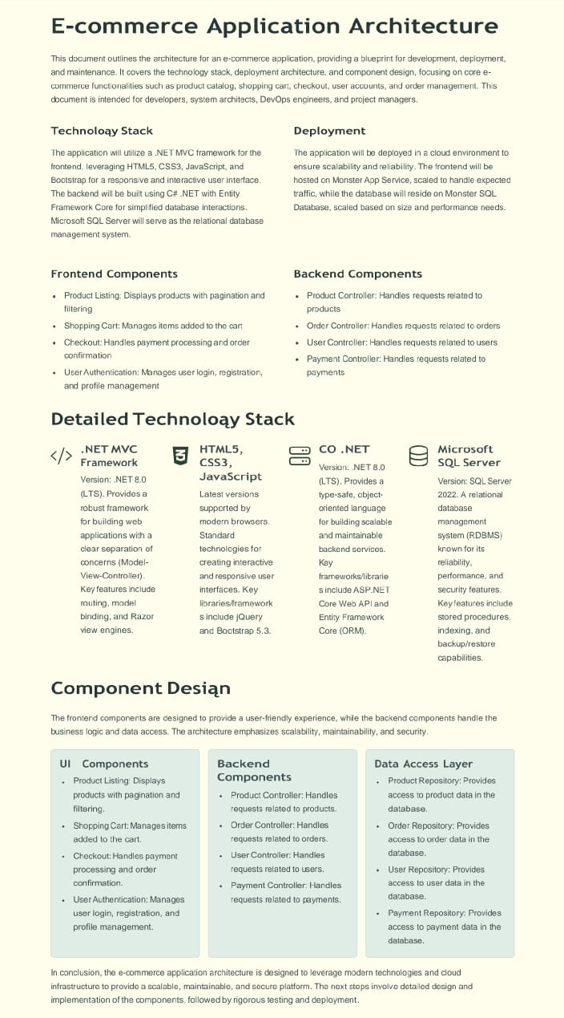

# ER Diagram

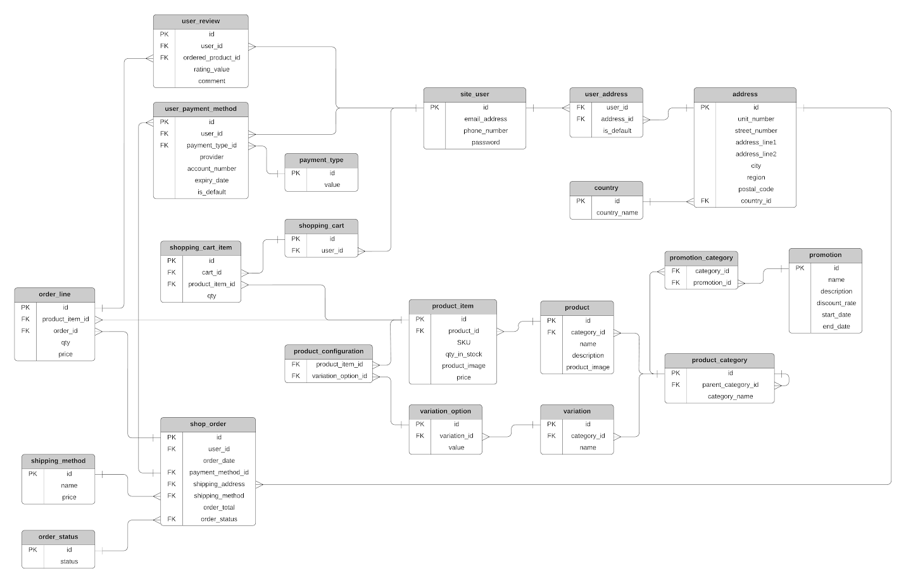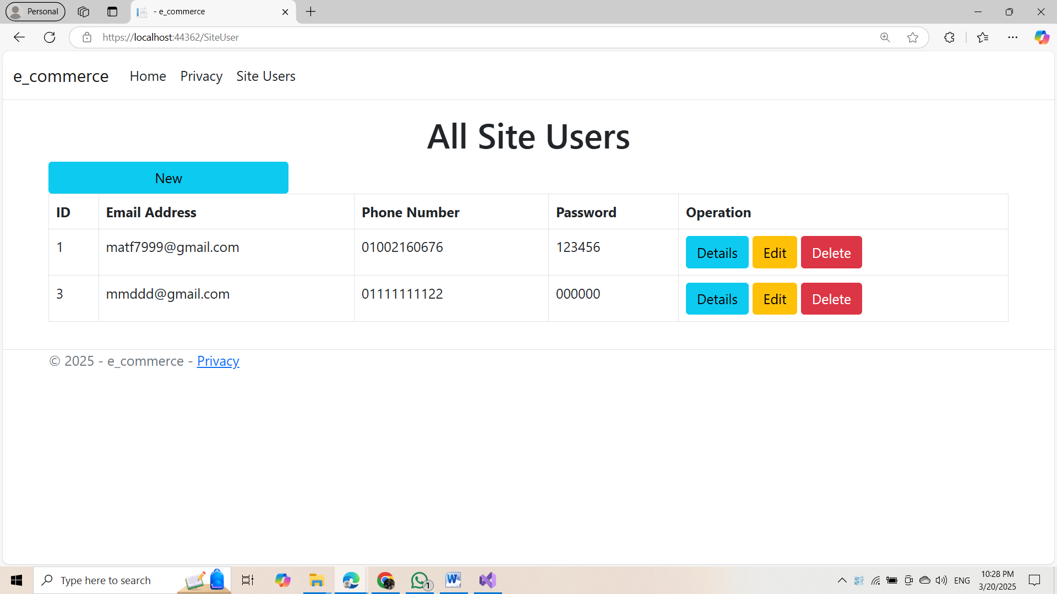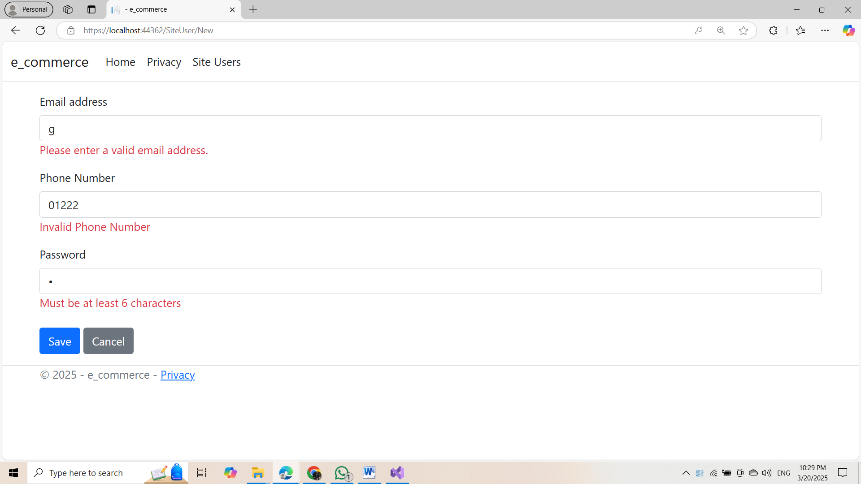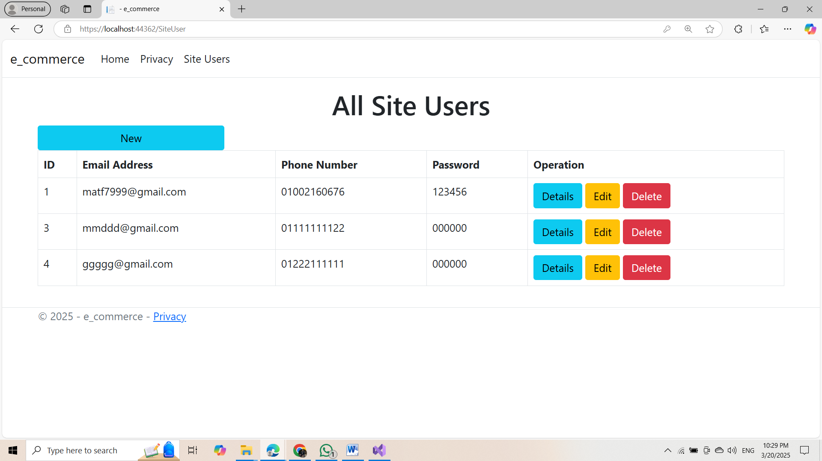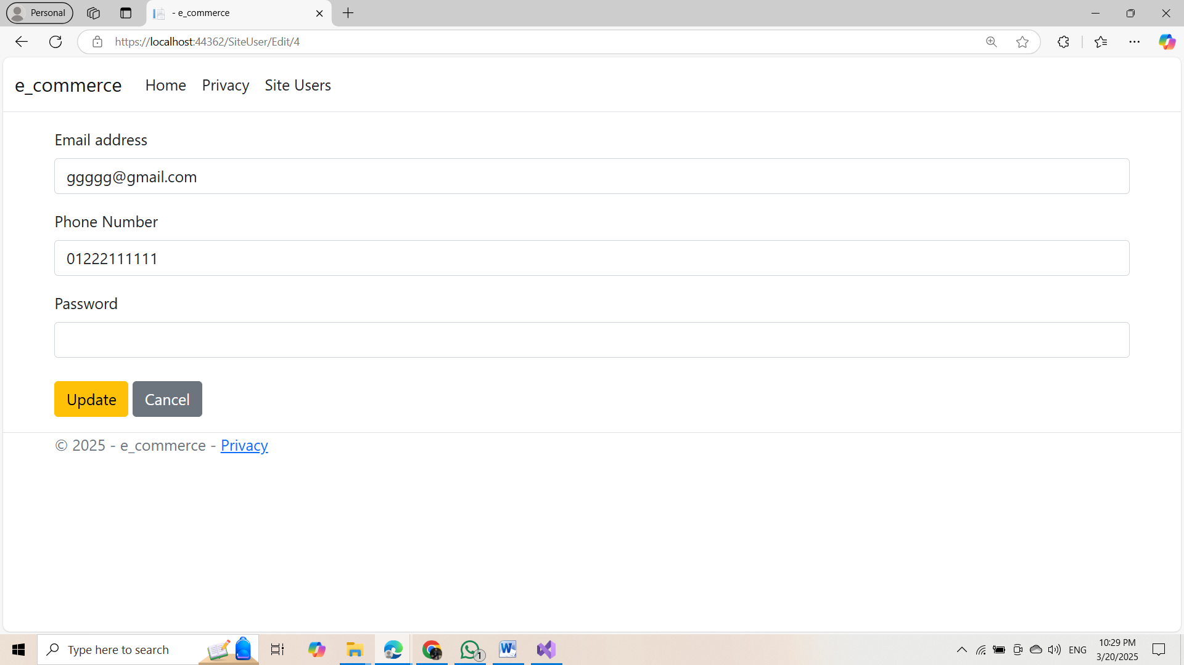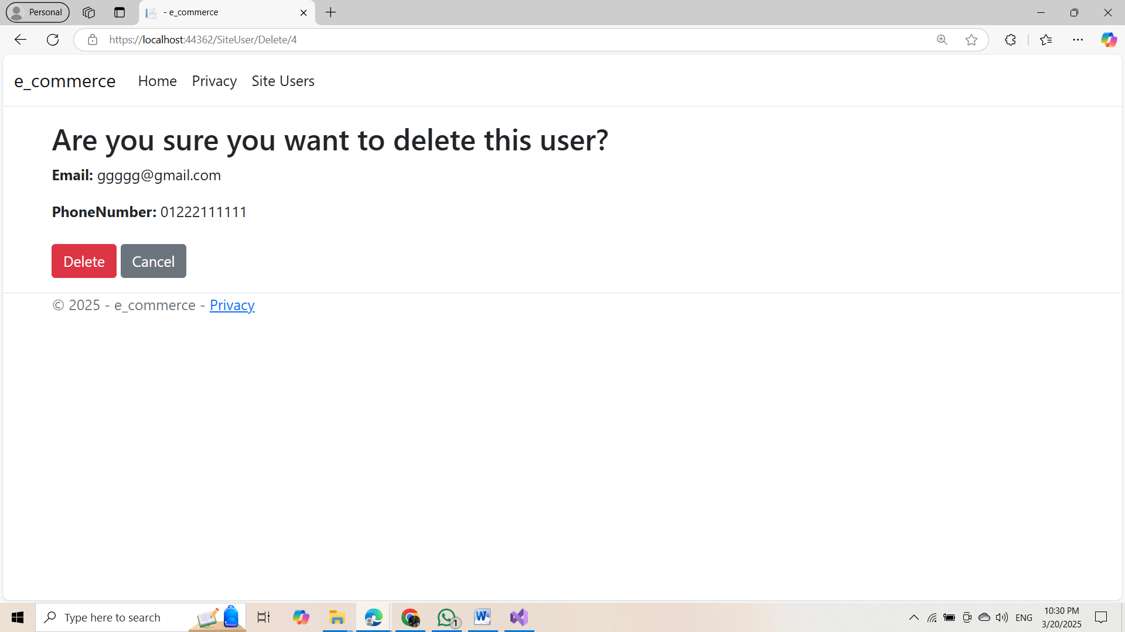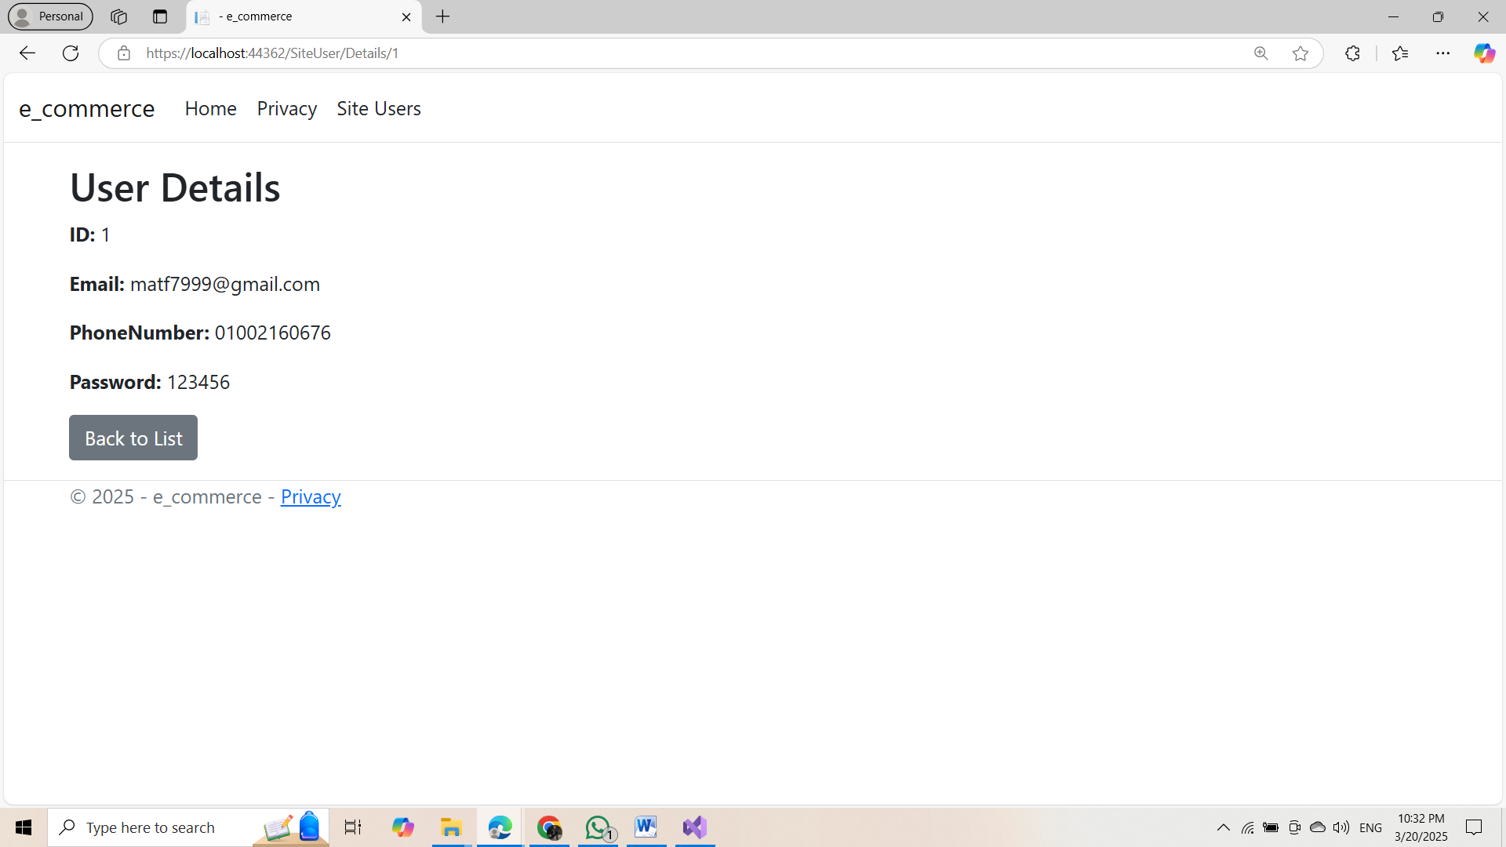

# Repository & Updates

You can find the complete source code for the **Electronics E-commerce Application** on GitHub:

<https://github.com/MahmoudAtefHamed/CAI2_SWD5_S11_Team1_TechXpress-E-Commerce>

### This repository will be **regularly updated** with improvements, bug fixes, and new features. Stay tuned for the latest updates!